SIMATS ENGINEERING
Department of Artificial Intelligence and Data Science
SOFTWARE ENGINEERING
Case Study Analysis Report
Intelligent AI-Based Marine Pollution Monitoring
and Coastal Protection System
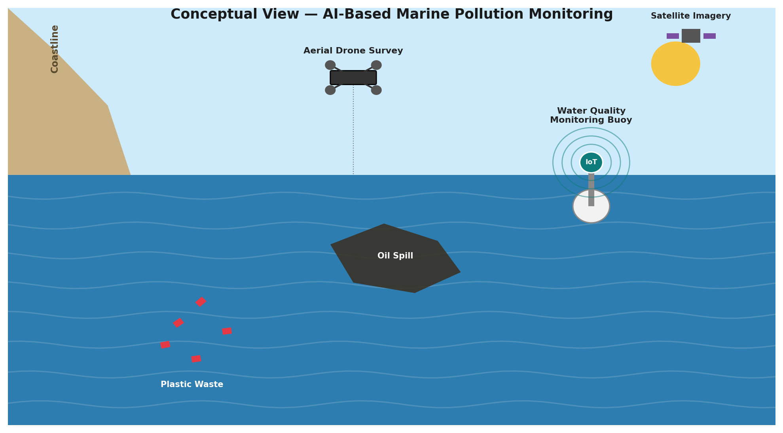
Conceptual overview of AI-based marine pollution monitoring

Name | B. Bindhu
Register Number | 192524472
Department | Artificial Intelligence and Data Science
Subject | Software Engineering
Faculty | Dr. Latha. R
College | SIMATS Engineering
Academic Year | 2025 – 2029

1. Understanding the Problem Statement

1.1 Problem Explanation
Marine ecosystems along coastlines are under increasing pressure from industrial discharge, accidental oil spills, uncontrolled plastic waste disposal, and untreated sewage entering coastal waters. These sources of pollution degrade water quality, destroy marine habitats, and threaten the livelihoods of coastal communities that depend on fishing and tourism. Environmental agencies responsible for protecting these waters currently rely on periodic field inspections carried out by boat crews or shore-based teams, which are conducted only occasionally due to cost, distance, and staffing constraints.
The core problem addressed in this case study is that traditional, manual monitoring cannot detect contamination events as they happen. By the time a field inspection identifies a pollution event, the contaminant may have already spread across a wide area, causing irreversible ecological damage and requiring far more expensive cleanup operations than early intervention would have needed. There is a clear need for an AI-powered marine monitoring platform that continuously gathers environmental data from water quality sensors, aerial drones, and satellite imagery, uses artificial intelligence to detect pollution as it occurs, predicts how it will spread, traces it back to its likely source, and issues early warning alerts to the relevant response teams.

1.2 Objectives of the Proposed System
- Monitor coastal water quality continuously using networked sensors and remote sensing.
- Detect marine pollution events (oil spills, plastic accumulation, chemical discharge) using AI-based analysis.
- Predict the spread of detected pollution using oceanographic and weather-informed models.
- Identify the likely sources of pollution to support enforcement and accountability.
- Generate real-time environmental alerts for response teams and regulatory bodies.
- Support coastal conservation efforts through data-backed decision-making.
- Produce structured environmental monitoring reports for regulators and researchers.
- Improve overall marine ecosystem management through continuous, long-term data collection.

1.3 Scope of the Problem
The scope of this system covers coastal and near-shore marine zones that are most vulnerable to industrial discharge, shipping traffic, and land-based runoff. It is intended to serve environmental protection agencies, coast guard and marine response units, port authorities, and coastal communities across a regional coastline. The platform focuses on detection, prediction, source identification, and alerting; it does not extend to automated physical containment or cleanup operations (such as deploying containment booms), although integration with such systems is a plausible future extension. The solution is designed to scale from a pilot deployment along a single stretch of coastline to a national coastal monitoring network covering multiple ports and marine protected areas.

2. Key Stakeholders and Challenges

2.1 Stakeholders, Roles, and Responsibilities
Stakeholder | Role / Responsibility
Environmental Protection Agencies | Primary regulators who use the platform's dashboards and reports to monitor coastal water quality and enforce environmental regulations.
Coast Guard / Marine Response Teams | Receive real-time alerts to coordinate rapid response and containment operations during active pollution events.
Port Authorities & Shipping Companies | Monitor compliance with discharge regulations and use source-identification data to investigate incidents linked to vessel traffic.
Fishing Communities & Local Residents | Depend on healthy coastal waters for their livelihoods; benefit from public alerts and awareness reports on water safety.
Industrial Facilities (Coastal) | Subject to monitoring for discharge compliance; may be identified as pollution sources through the platform's analytics.
Researchers & Conservation Organizations | Use historical monitoring data and reports to study ecosystem health trends and support conservation planning.
System Administrators / IT Team | Maintain sensor networks, drone operations, cloud infrastructure, AI models, and ensure continuous system availability.
Tourism Boards & Local Government | Use environmental quality reports to inform beach safety advisories and coastal development planning.

2.2 Major Challenges Faced by Stakeholders
- Environmental agencies cannot cover the full extent of a coastline through periodic manual inspections, leaving large stretches unmonitored for long periods.
- Pollution events such as oil spills spread rapidly with tides and currents, so delayed detection significantly increases the area affected and the cost of cleanup.
- Identifying the responsible source of a pollution event after the fact is difficult without continuous data, making enforcement and accountability weak.
- Coast guard and response teams often receive reports of pollution well after the event has already caused significant ecological harm, reducing the effectiveness of any response.
- Coastal communities and fishermen lack timely, reliable information about water safety, which can result in health risks or economic losses.
- Integrating data from disparate sources — sensors, drones, satellites, and citizen reports — into a single coherent picture is a significant technical and organizational challenge.
- Remote or open-water monitoring locations face connectivity constraints that can disrupt continuous data transmission.

3. Analysis of the Current Approach

3.1 Existing System / Current Process
Marine pollution monitoring today is conducted primarily through scheduled field inspections, in which environmental agency staff travel by boat to designated sampling points along the coastline to manually collect water samples. These samples are transported to laboratories for analysis, a process that can take several days to produce results. Visual inspections for oil slicks or floating debris are typically carried out by patrol boats or occasional aerial overflights, and are heavily dependent on weather conditions and staff availability. Satellite imagery, where used at all, is generally accessed only after a pollution event has already been reported through other means, rather than being used as a continuous early-detection tool. Reports of pollution from members of the public or fishing crews are often received through informal channels such as phone calls, with no centralized system to log, verify, or act on them systematically.

3.2 Strengths of the Existing System
- Laboratory-based water sample analysis provides highly accurate, detailed chemical composition data when performed.
- Established regulatory and legal frameworks already exist for enforcement once a pollution source is identified.
- Field teams bring valuable local knowledge of coastal conditions, tides, and known industrial discharge points.

3.3 Limitations of the Existing System
- Infrequent sampling schedules mean that pollution events occurring between inspections can go undetected for days or weeks.
- Laboratory turnaround times delay the confirmation of contamination, during which pollution continues to spread unchecked.
- Visual inspections are limited by weather, daylight, and vessel availability, and cannot cover large coastlines comprehensively.
- There is no systematic integration of sensor, aerial, satellite, and citizen-reported data, resulting in fragmented and inconsistent situational awareness.
- The current approach has no predictive capability, so responders can only react to pollution after it has already caused damage rather than anticipating its spread.
- Source identification is largely investigative and manual, making it difficult to hold polluters accountable in a timely manner.

3.4 Gaps to Be Addressed
The proposed platform must close several critical gaps: the lack of continuous, automated environmental monitoring; the absence of integration across sensor, drone, satellite, and citizen-reported data streams; the complete absence of predictive spread modelling; the lack of systematic, data-driven source identification; and the absence of a centralized, real-time alerting mechanism for coast guard and response teams.

4. Proposed Software Solution

4.1 Solution Overview
The proposed solution is an Intelligent AI-Based Marine Pollution Monitoring and Coastal Protection System that continuously ingests data from water quality sensors, aerial drones, and satellite imagery, processes this data through cloud-based AI detection and prediction engines, and delivers real-time alerts and analytics to environmental agencies, coast guard teams, and the public. The system follows a layered, modular architecture that combines IoT sensing, remote sensing, cloud computing, and artificial intelligence, as illustrated below.
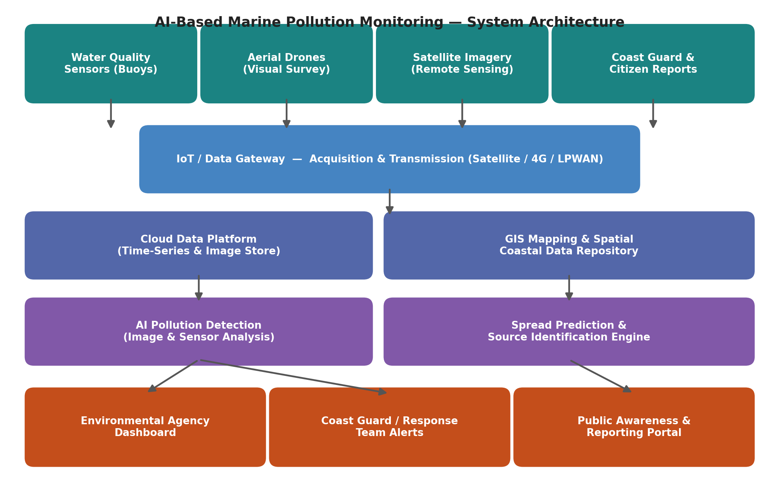
Figure 1: Layered system architecture of the proposed marine pollution monitoring platform

4.2 Major Functional Modules
Module | Description
Water Quality Sensing Module | Collects continuous data on pH, turbidity, dissolved oxygen, and chemical indicators from networked buoy-mounted sensors along the coastline.
Aerial Drone Survey Module | Coordinates scheduled and event-triggered drone flights to visually survey coastal waters and capture high-resolution imagery of suspected pollution.
Satellite Imagery Integration Module | Ingests satellite remote-sensing data to detect large-scale surface anomalies such as oil slicks or algal blooms across wide coastal areas.
AI Pollution Detection Module | Applies computer vision and sensor-fusion machine learning models to identify pollution events from imagery and sensor readings.
Spread Prediction Module | Uses oceanographic models incorporating tides, currents, and wind data to forecast how detected contamination will move over time.
Source Identification Module | Cross-references detected pollution location, drift patterns, and known industrial/shipping activity data to estimate likely pollution sources.
Alerting & Notification Module | Sends real-time alerts to coast guard, environmental agencies, and registered coastal communities when pollution is detected or predicted to spread nearby.
Reporting & Compliance Module | Generates structured environmental monitoring reports for regulators, supporting compliance tracking and long-term ecosystem trend analysis.
Citizen Reporting Portal | Allows fishermen and coastal residents to submit geo-tagged pollution reports and photos, supplementing automated detection.
User & Access Management Module | Manages secure, role-based access for agency staff, coast guard personnel, and the public, with appropriate data privacy controls.

4.3 Functional Requirements
- The system shall continuously collect water quality data from deployed buoy sensors at defined coastal monitoring points.
- The system shall process satellite and drone imagery using AI models to detect pollution events such as oil spills or plastic accumulation.
- The system shall generate predictive maps showing the likely spread of detected pollution over a configurable time horizon.
- The system shall estimate probable pollution sources based on drift analysis and known industrial or vessel activity.
- The system shall issue automated alerts to coast guard and environmental agency dashboards when pollution is detected.
- The system shall allow citizens to submit geo-tagged pollution reports through a public-facing portal.
- The system shall generate periodic environmental compliance reports for regulatory submission.

4.4 Non-Functional Requirements
Quality Attribute | Description
Scalability | The system must scale from monitoring a single coastal stretch to an entire national coastline without major architectural redesign.
Reliability | Given its role in triggering emergency response, the platform should maintain at least 99.5% uptime for detection and alerting services.
Maintainability | Modular design should allow the AI detection models or drone integration to be updated independently of other components.
Usability | Dashboards for coast guard and agency staff must present critical alerts clearly and prioritize actionable information during emergencies.
Security | Sensor data, imagery, and source-identification records must be encrypted and access-controlled to prevent tampering or unauthorized disclosure.
Performance | Pollution detection alerts should be generated within minutes of data ingestion to support genuinely early warning capability.

4.5 Application of Software Engineering Principles
- Modularity: The platform is decomposed into independent modules (sensing, drone survey, satellite integration, AI detection, prediction, alerting) that can be developed, tested, and deployed separately, reducing coupling and simplifying maintenance.
- Scalability: A cloud-native, microservices-based design allows the system to scale horizontally as additional monitoring buoys, drones, and coastal regions are added over time.
- Maintainability: Clear module boundaries and documented interfaces allow the AI detection or prediction models to be retrained and updated without disrupting other system components.
- Reliability: Redundant data pipelines and health-monitoring of sensors and drones ensure that individual hardware failures do not compromise overall system availability.
- Usability: Role-specific dashboards present coast guard and agency users with clear, prioritized alerts, while the citizen reporting portal is designed for simple, accessible public use.
- Security: End-to-end encryption, role-based access control, and audit logging protect sensitive source-identification and compliance data from tampering or misuse.

5. Justification of the Chosen Methodology / Framework

5.1 Selected Methodology: Agile (Scrum Framework)
The Agile methodology, implemented through the Scrum framework, has been selected for the development of this platform. The project integrates several evolving and technically complex components — IoT sensor networks, drone-based imagery, satellite data integration, and AI-based detection and prediction models — each of which benefits from iterative refinement based on real-world testing. Combined with the diverse needs of stakeholders ranging from environmental regulators to coast guard responders and the general public, an incremental, feedback-driven approach is best suited to this project rather than a rigid, sequential model.
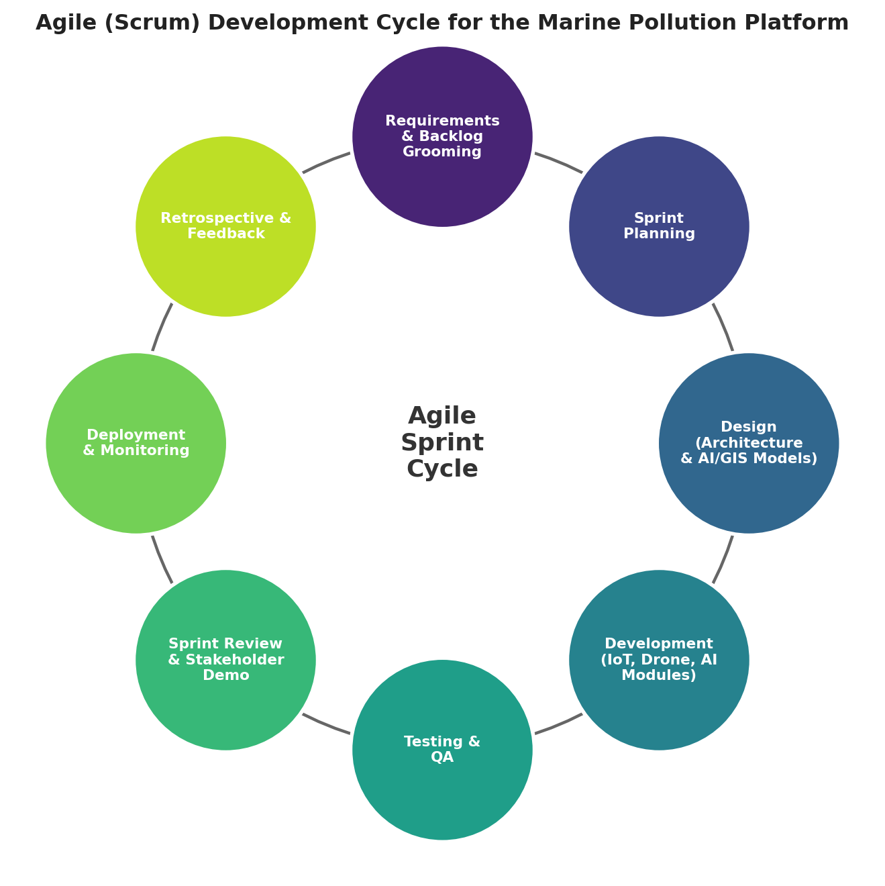
Figure 2: Agile (Scrum) development cycle applied to the platform

5.2 Justification for Selecting Agile/Scrum
- Evolving Requirements: AI detection and prediction models require ongoing refinement as more field data becomes available, which Agile accommodates through iterative sprints rather than a fixed upfront design.
- Stakeholder Feedback: Frequent sprint reviews allow coast guard teams, environmental agencies, and citizen users to validate features such as alert clarity and reporting workflows early and often.
- Independent Modules: Since the system is modular (sensing, drone integration, AI detection, prediction, alerting), each module can be developed and delivered through separate, parallel sprint tracks.
- Risk Reduction: Incremental delivery allows early testing of high-risk components — such as AI detection accuracy on real imagery and drone connectivity over open water — before the full system is finalized.
- Faster Time-to-Value: A working pilot covering a limited coastal stretch with basic detection and alerting can be delivered within the first few sprints, enabling early real-world validation.

5.3 How Agile Supports Successful Development and Maintenance
Agile's sprint-based structure keeps development continuously aligned with stakeholder needs through regular backlog grooming and sprint reviews involving environmental agency and coast guard representatives. End-of-sprint retrospectives allow the development team to address emerging technical challenges, such as inconsistent sensor readings or drone connectivity issues, and refine processes accordingly. After deployment, the same Agile cadence supports ongoing maintenance — incorporating new sensor types, retraining AI models with newly collected pollution event data, and adapting to changing environmental regulations — making it well suited to both the platform's initial development and its long-term evolution.

6. Expected Outcomes and Limitations

6.1 Expected Benefits
- Early detection of pollution events, significantly reducing response time compared to periodic manual inspections.
- Improved coastal protection through continuous monitoring of vulnerable marine zones.
- Better environmental monitoring supported by integrated sensor, drone, and satellite data.
- Reduced ecological damage as a result of faster containment and response to pollution events.
- Enhanced conservation planning through long-term environmental data and trend analysis.
- Increased regulatory compliance due to improved source identification and accountability.
- Sustainable marine resource management supported by data-driven decision-making.
- Improved public environmental awareness through the citizen reporting portal and public advisories.

6.2 How the Solution Addresses Identified Challenges
By replacing infrequent manual inspections with continuous, automated monitoring, the platform directly addresses the detection delay that currently allows pollution to spread unchecked. AI-based spread prediction closes the gap between passive observation and proactive response, giving coast guard and agency teams the ability to anticipate contamination movement rather than react after damage has occurred. Systematic source identification strengthens enforcement, while the citizen reporting portal extends monitoring coverage into areas not directly served by sensors or drones.

6.3 Potential Risks and Implementation Challenges
- Initial deployment and maintenance costs for buoy sensors, drones, and satellite data access across an extended coastline.
- Connectivity limitations in open-water or remote coastal areas may affect the consistency of real-time data transmission.
- Accuracy of AI detection and source-identification models depends on the availability of sufficient historical pollution event data for training.
- Coordinating data sharing and response protocols across multiple agencies, coast guard units, and port authorities can be organizationally complex.
- False positives in automated detection could lead to unnecessary alarm or response costs if not carefully calibrated.

6.4 Limitations of the Proposed System
The current scope of the platform is limited to detection, prediction, source identification, and alerting; it does not include automated physical containment or cleanup of detected pollution, which would require integration with separate response infrastructure. Detection and prediction accuracy may also be lower during the initial deployment phase due to limited historical training data, and system effectiveness in extremely remote open-water areas may be constrained by connectivity.

6.5 Future Enhancements
- Integration with automated containment infrastructure, such as deployable containment booms, to enable direct response to detected spills.
- Expansion of AI models to incorporate climate and seasonal weather pattern data for more accurate long-term pollution risk forecasting.
- Blockchain-based compliance and incident record-keeping to improve transparency in regulatory enforcement.
- Integration with underwater sensor networks to extend monitoring below the surface for subsurface contamination detection.
- Expanded citizen engagement features, such as gamified reporting incentives, to further increase public participation in coastal monitoring.

